Concept: | Image |  | Definition | Example
“6 Traits of Effective Writing”  ________________  Synonyms:  Traits = attribute or characteristic  Effective = successful or powerful | There, there… I can write well! |  | Idea Development  Organization  Voice  Word Choice  Sentence Fluency  Conventions (grammar) | Good writing is…  Clear (grammar, organization)  and  Interesting(voice, word choice, sentence fluency)  to its  Particular Audience (Idea Development)  It requires that all 6 traits work together in unison to achieve effective writing
I can teach someone about this!!! | I think I understand this concept. |  | I am struggling to understand | I do not understand this at all

Concept: | Image |  | Definition | Example
Revision  Strategies  Synonyms:  Revise = reassess, alter, change, rephrase, rewrite  Strategy = plan of action, plan of attack | 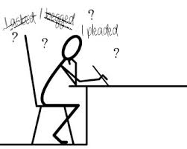 |  | 1) To increase sentence fluency highlight the first word of every sentence and look for new ways to start sentences.  2) Circle and Delete worn out words: a lot, very, nice, really, so, well, big, fun, got  3) Add transition words:  In addition, furthermore, moreover, in particular, for instance, ultimately, to begin | 4) Use “It’s possible that” to test for complete sentences and fragments and correct them.  5) Combine sentences using the semi-colon (;) dash (---) or comma FANBOYS  for, and, nor, but (use however), or, yet, so  6) Replace “you” with an individual, one, people, a person, or the name of the specific group—students etc;
I can teach someone about this!!! | I think I understand this. |  | I am struggling to understand. | I do not understand this at all.

